Software Architecture Document

- Tech-Stack
- Frontend: NEXT.js – routing, Proxy/BackendForFrontend
  - TailwindCSS
  - Framer Motion (animations)
  - ShadCN (UI library)
- Backend: ASP.NET (Identity, EF Core) – Modular Monolith
- SQL: PostgreSQL – structured data
- Container(s): Docker + Linux
- File storage: Linux Docker – binary files (PDF’s, images, videos)

- C4 Diagram
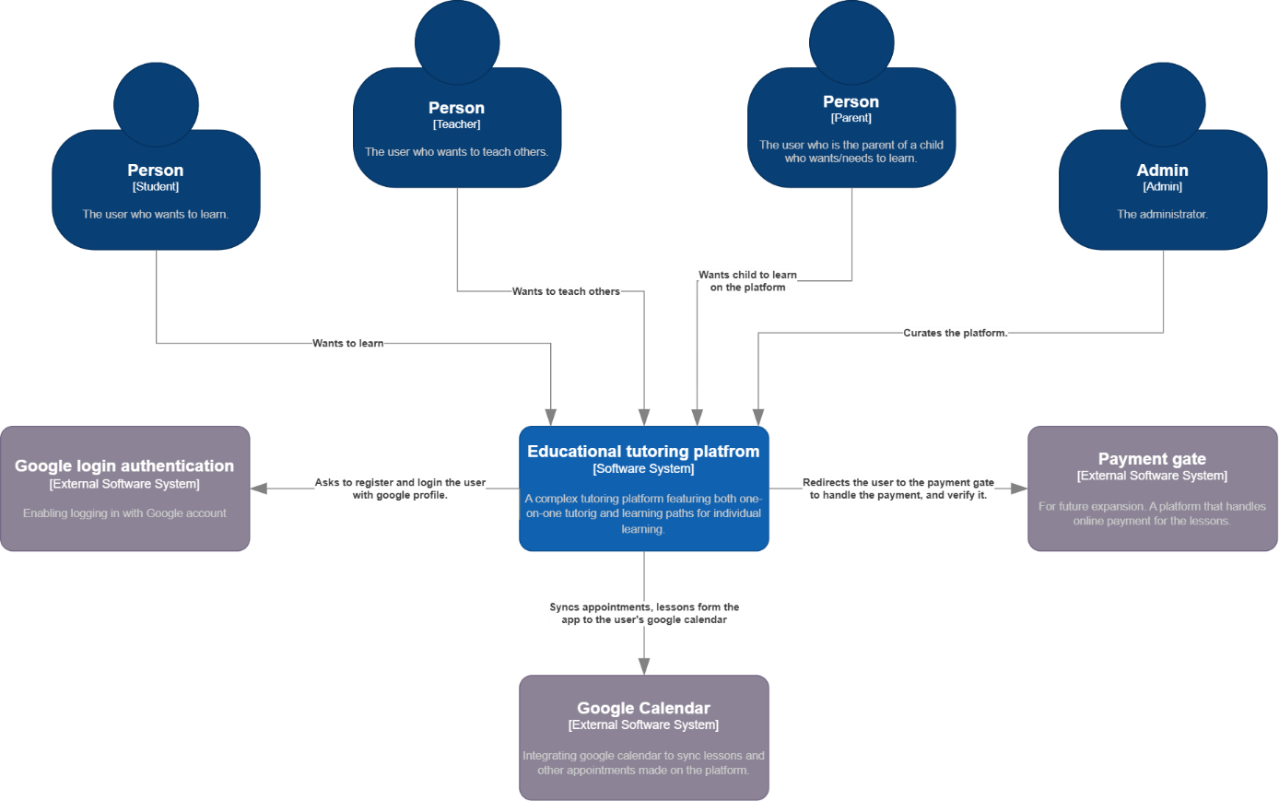
- Level 1:
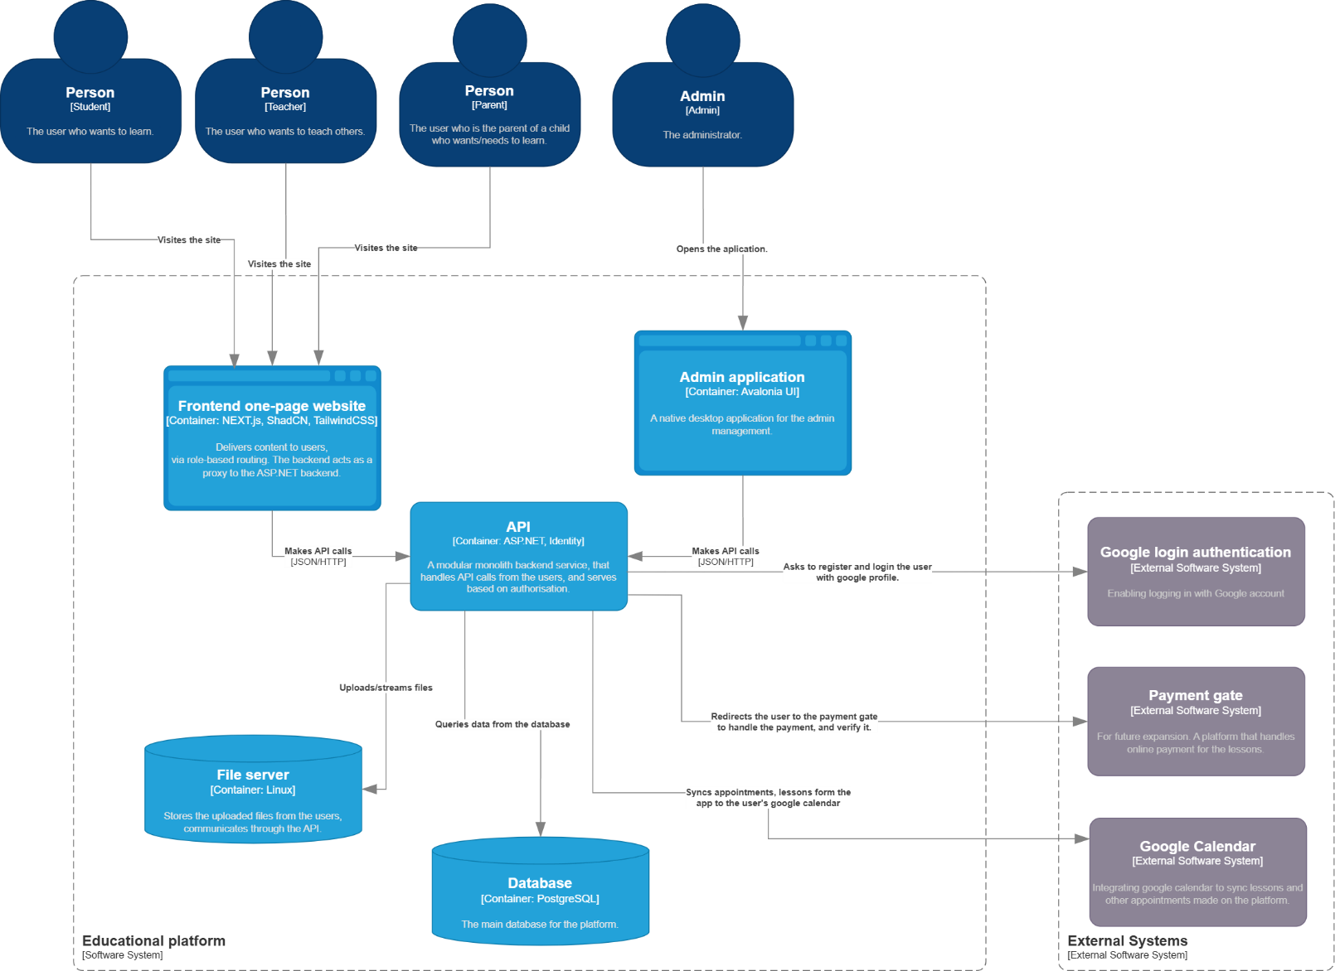
- Level 2:

  - Frontend: Delivers content to users, via role-based routing. The backend acts as a proxy to the ASP.NET backend.
  - API: A modular monolith backend service, that handles API calls from the users, and serves based on authorization.
  - File Server: Stores the uploaded files from the users, communicates through the API.
  - Database: The main relational database for the platform.
  - External systems:
    - Google Login Auth: Enabling logging in with a Google Account for convenience.
    - Google Calendar: Integrates with the built in scheduling API module, lessons and other appointments show up in the synced calendar too.
    - Payment gate: For future expansion. A platform that handles online payment for the lessons.
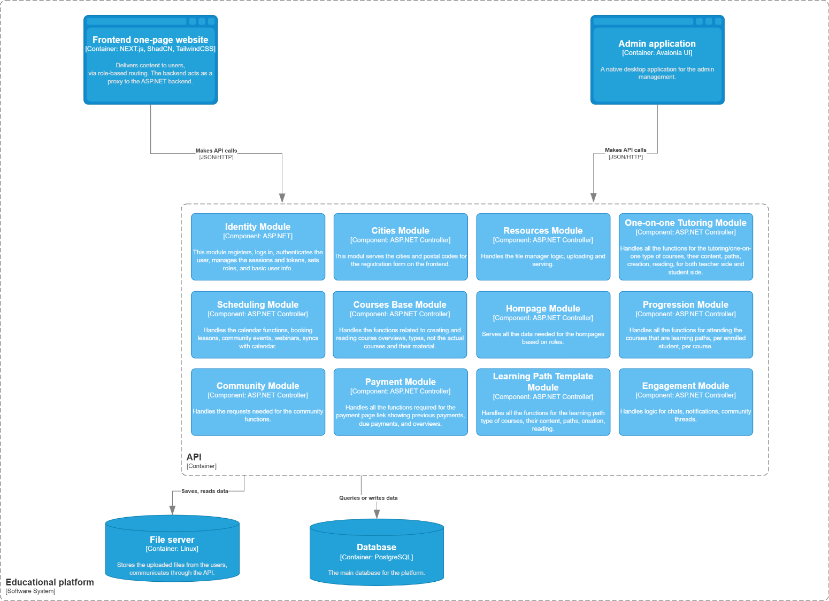
- Level 3:

  - Identity Module: This module registers, logs in, authenticates the user, manages the sessions and tokens, sets roles, and basic user info.
  - Cities Module: This module serves the cities and postal codes for the registration form on the frontend.
  - Resources Module: Handles the file manager logic, uploading and serving.
  - Scheduling Module: Handles the calendar functions, booking lessons, community events, webinars, syncs with calendar.
  - Courses Base Module: Handles the functions related to creating and reading course overviews, types, not the actual courses and their material.
  - Homepage Module: Serves all the data needed for the homepages based on roles.
  - Learning Path Template Module: Handles all the functions for the learning path type of courses, their content, paths, creation, reading.
  - Progression Module: Handles all the functions for attending the courses that are learning paths, per enrolled student, per course.
  - Tutoring Module: Handles all the functions for the tutoring/one-on-one type of courses, their content, paths, creation, reading, for both teacher side and student side.
  - Community Module: Handles the requests needed for the community functions.
  - Engagement Module: Handles logic for chats, notifications, community threads.
  - Payment Module: Handles all the functions required for the payment page like showing previous payments, due payments, and overviews.

- Domain Model
  - Identity Domain:
    - Entities:
      - User: Can be a student, teacher, or parent
      - Profile: Stores role-based information
    - Relationships:
      - One user -> one profile
      - One user -> many enrollments
      - One user -> many tutoring rooms
      - One teacher -> many courses
      - One parent -> multiple students
  - Course Base Domain:
    - Entities:
      - Course: Can be either a learning path or a tutoring course, the basic information about it
    - Relationships:
      - One teacher -> multiple base courses
      - One base course -> either learning path or tutoring NOT both
  - Learning Path Domain:
    - Entities:
      - Learning Path: The template the teacher creates for the course.
      - Unit: A section of the path, grouped together by the teacher
      - Lesson: A single piece of content, can be any content type
    - Relationships:
      - One base course (learning path type) -> one learning path
      - One learning path -> multiple units
      - One unit -> multiple lessons
      - One lessons -> multiple content items
      - Lesson: must be in one unit
      - Unit: must be in one path
  - Tutoring Domain:
    - Entities:
      - Tutoring Room: The link between a student and a teacher
      - Personal Wall: A stream of items sent in the room
      - Wall Item: A polymorphic content entity
    - Relationships:
      - One base course (tutoring type) -> multiple tutoring room (one per student)
      - One room -> one personal wall
      - One personal wall -> multiple items (content)
      - One student -> multiple tutoring rooms (by teachers)
  - Content Domain:
    - Entity: Content Item:
      - File: Any uploaded file (e.g. PDF, Word, PPT, TXT, Video, Audio, Image) – stored as binary
      - Test: A series of sub-modules made in the test editor, the student has to fill out, can have timer, and be graded
      - Hand-in: A text which describes what the student should submit by the due date, type can be selected, and if one or multiple types (e.g. image, word, pdf, ppt, text)
      - Text: Simple, formatted text can be sent or stored
      - Test module: Blocks a test can be built out of, can be graded (e.g. short-long answer, select one-multiple, sort)
    - Relationships:
      - Test -> many modules
      - One content item -> one type
      - One hand-in -> one submission
      - One content item can belong: Lesson, Wall, Submission, Thread, and can be reused across multiple places
  - Scheduling Domain:
    - Entities:
      - Event: Any scheduled real time activity, can be a tutoring lesson, a consultation on a learning path, a consultation with a parent, a community event or webinar
    - Relationships:
      - One tutoring room -> multiple events (lessons)
      - One learning path enrollment -> multiple events (consultations)
      - One learning path -> multiple events (webinars tied to one path)
  - Engagement Domain:
    - Entities:
      - Message: Any text sent to another user or thread
      - Thread: A room for community texts, content and events
      - Chat Room: A communicational channel between two users for messages
    - Relationships:
      - One chat room/thread -> multiple messages
      - One tutoring room -> one chat room (optional)
      - One learning path -> one thread (optional)
      - One learning path enrollment -> one chat room (optional, student – teacher support)
  - Progression Domain:
    - Entities:
      - Enrollment: Stores data about the progress the student makes when enters a learning path
      - Submission: Stores the content item the student hands in
      - Feedback: The grading and/or the comment the teacher gives to the test/hand-ins
    - Relationships:
      - One learning path -> multiple enrollments (per student)
      - One enrollment -> one chat room (student - teacher)
      - One hand-in -> one submission
      - One submission -> multiple content items (multi file submission)
      - One submission -> one feedback
  - Cities Domain:
    - City: A city or town with its postal code
  - Payment Module:
    - Entities:
      - Payment: Stores the price, the deadline for the payment, the user who made the purchase, and whether it was already paid
    - Relationships:
      - One enrollment -> multiple payments
      - One tutoring room -> multiple payments
      - One payment -> one type of course (per enrollment/tutoring room)

